**INTRODUCTION**

* 1. **Introduction:**

The Internet of Things, or IoT, refers to the billions of physical devices around the world that are now connected to the internet, collecting and sharing data. Thanks to cheap processors and wireless networks, it's possible to turn anything, from [a pill](https://www.zdnet.com/article/how-sensors-enabled-eli-lilly-to-improve-the-patient-experience/) to [an aeroplane](https://www.zdnet.com/article/ten-examples-of-iot-and-big-data-working-well-together/) to a self-driving car into part of the IoT. This adds a level of digital intelligence to devices that would be otherwise dumb, enabling them to communicate real-time data without a human being involved, effectively merging the digital and physical worlds.

In this project we are using IoT to operate motor in clockwise and anti-clockwise direction, turning on and off a DC fan and AC bulb.

* 1. **Theoretical Background:**

Arduino is used in the project to interface mobile with wi-fi module. Mobile is used as router. Buttons are designed in GUI for wi-fi module to control motor, fan and bulb.

Project was first designed in cisco packet tracer where IoT server was first created in the server0, than every device was connected with the server and was controlled by server. Arduino was also used and it was also having a separate programming for each device and each device could be controlled from arduino also.

**PROJECT BLOCK DIAGRAM**

**2.1 Block Diagram:**

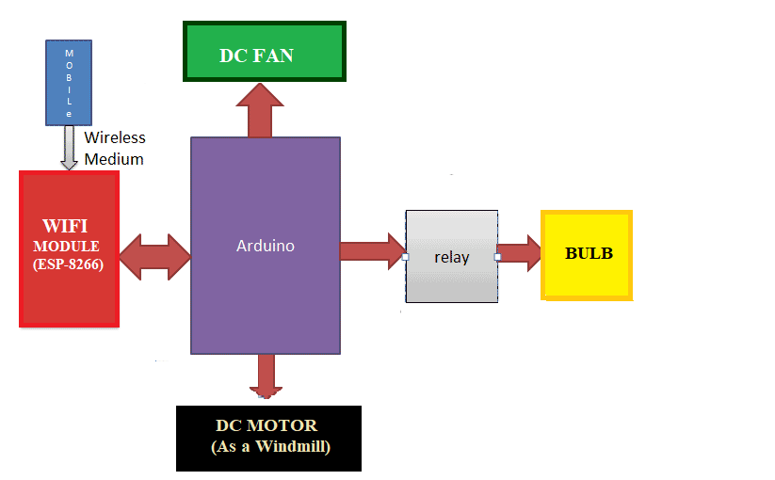

**2.2 Description of Blocks:**

**Arduino:**

Arduino is controller for project. Wires of bulb, fan and motor are connected with arduino. Button for each device has been created in software of arduino IDE. Anything from wi-fi module will be first send to arduino and then to device.

**Wi-Fi Module:**

Wi-Fi module is connecting each device with internet. From hardware perspective, it incorporates microcontroller, MAC, baseband, and RF front end. The data is transmitted and received over radio frequency.

From software perspective, it implements most of the 802.11 MAC protocols (SSID broadcasting, authentication/association for clients, encapsulating/decapsulating packets, transmitting/receiving packets, etc.) and partial 802.11 PHY protocols. Some 802.11 MAC protocols are implemented in the chipset, such as packet encryption and decryption, for software offload.

**Mobile Used As Router:**

Mobile is being used as router. When any button is pressed in GUI it sends signals to wi-fi module and wi-fi module further send signals to controller and corresponding step is taken.

**METHODOLOGY**

It is a good practice to design the scenario in software before implementing it into hardware or practical. First we designed the project in cisco packet tracer. Server was used in software which was controlling all the IoT devices. Each IoT device was connected with server. Arduino was also used which was having a separate programming for each and every device and IoT device was also controlled by arduino.

In hardware, we used arduino and a wi-fi to control IoT devices. Mobile was used as a server. Buttons were designed in arduino and each and every button has a different feature for each device. Blynk app was used which was connecting mobile with wi-fi module. Motor was rotating clockwise and anti clockwise while AC bulb and DC fan was turned on and off. Mobile was sending signal to wi-fi module and wi-fi was further sending signals to controller and controller was further controlling the device.

|  |  |  |
| --- | --- | --- |
| **S.No** | **Quantity** | **Remarks** |
| 1. | Arduino | Used for controlling IoT device. Signal received from Wi-Fi module. |
| 2. | Wi-Fi Module | Connected to mobile. Receiving signals from mobile and sending to controller. |
| 3. | Mobile | Sending signals to wi-fi module to control the IoT device. |

**Configuring the Simulation Concepts In Cisco Packet Tracer :**

In building smart home network can be implemented through the simulation concept designed on cisco packet tracer. Some of the tools needed to build a smart home network are home gateways that function as transmission media paths and provide automatic addressing to multiple devices connected via wireless networks, smartphones that serve as interfaces in controlling and monitoring electronic devices, and some devices to be controlled based on conditions set on smartphone devices . In figure 1 configure the smartphone device as an interface in monitoring and controlling electronic devices, then in figure 2 as the intermediate home gateway login on the smartphone device via the web browser, then in figure 3 as the interface list of IoT server electronic devices in the home menu located on the smartphone, then in figure 4 topology of given network to run following commands by IOT Server.

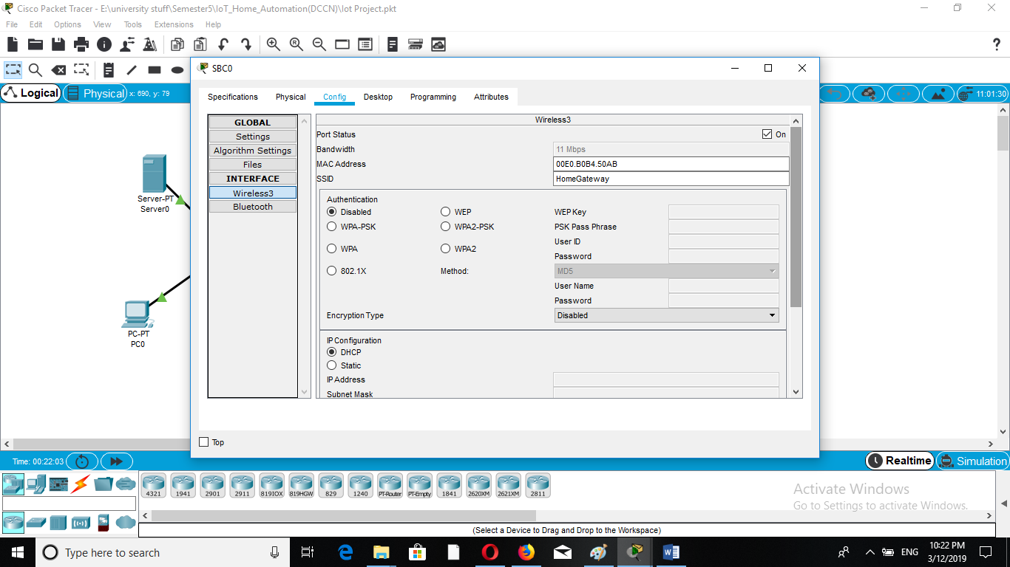

**Figure 1**. IoT server wireless settings.

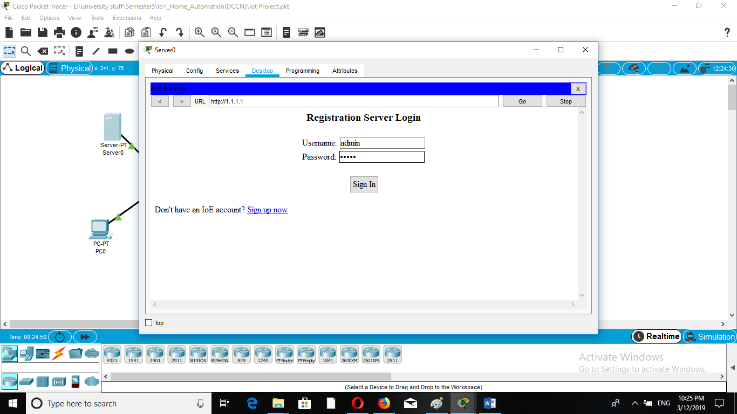

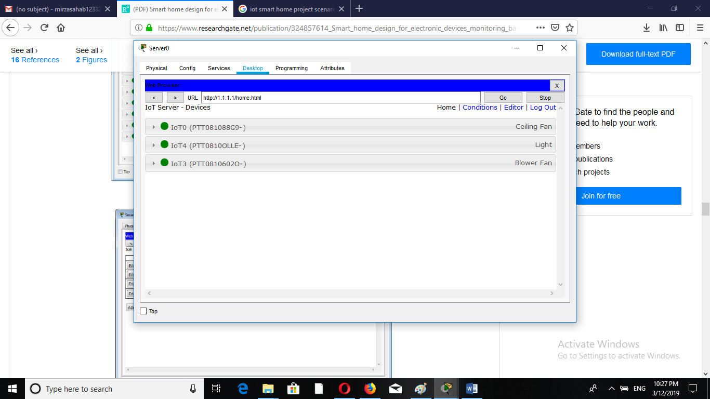 **Figure 2**. Home gateway smartphone login.

**Figure 3**. IoT server home device smartphone interface.

**Figure 4**. 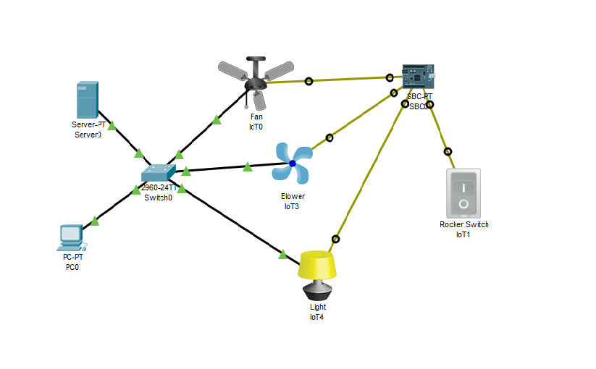Topology of IOT Smart Home.

**SYSTEM HARDWARE**

**Arduino UNO:**

The Arduino UNO is an open-source microcontroller board based on the [Microchip](https://en.wikipedia.org/wiki/Microchip_Technology) [ATmega328P](https://en.wikipedia.org/wiki/ATmega328P) microcontroller and developed by [Arduino.cc](https://en.wikipedia.org/wiki/Arduino). The board is equipped with sets of digital and analog input/output (I/O) pins that may be interfaced to various expansion boards (shields) and other circuits. The board has 14 Digital pins, 6 Analog pins, and programmable with the [Arduino IDE](https://en.wikipedia.org/wiki/Arduino#Software) (Integrated Development Environment) via a type B USB cable. It can be powered by a USB cable or by an external 9 volt battery, though it accepts voltages between 7 and 20 volts.

**Wi-Fi Module:**

The ESP8266 WiFi Module is a self contained SOC with integrated TCP/IP protocol stack that can give any microcontroller access to your WiFi network. The ESP8266 is capable of either hosting an application or offloading all Wi-Fi networking functions from another application processor.

**DC Motor:**

A DC motor is any of a class of rotary electrical machines that converts direct current electrical energy into mechanical energy. The most common types rely on the forces produced by magnetic fields.

**AC Bulb:**

AC bulb takes line voltage to give light. Atoms release light photons when their **electrons** become excited.

**DC Fan:**

DC fan is used to exhale hot air outside and inhale cool air inside.

**SYSTEM SOFTWARE**

**CISCO PACKET TRACER:**

Packet Tracer is a [cross-platform](https://en.wikipedia.org/wiki/Cross-platform) visual [simulation](https://en.wikipedia.org/wiki/Simulation) tool designed by [Cisco Systems](https://en.wikipedia.org/wiki/Cisco_Systems) that allows users to create [network topologies](https://en.wikipedia.org/wiki/Network_topologies) and imitate modern [computer networks](https://en.wikipedia.org/wiki/Computer_networks). The software allows users to simulate the configuration of Cisco routers and switches using a simulated command line interface.

**Arduino IDE:**

The [Arduino](https://en.wikipedia.org/wiki/Arduino) integrated development environment ([IDE](https://en.wikipedia.org/wiki/Integrated_development_environment)) is a [cross-platform](https://en.wikipedia.org/wiki/Cross-platform) application (for [Windows](https://en.wikipedia.org/wiki/Windows), [macOS](https://en.wikipedia.org/wiki/MacOS), [Linux](https://en.wikipedia.org/wiki/Linux)) that is written in the programming language [Java](https://en.wikipedia.org/wiki/Java_(programming_language)). It is used to write and upload programs to Arduino board.

**CONCLUSION AND FUTURE RECOMMENDATIONS**

**Conclusion:**

IoT devices are controlled by mobile through wi-fi. The wi-fi gives signal to controller and corresponding step is taken. Mobile is working as server or router. First scenario was designed in cisco packet tracer. Server was controlling IoT devices and devices could also be controlled by controller. In hardware, buttons are designed in arduino via blynk app and each and every device has different button for different operation.

**Future Recommendations:**

No doubt IoT deployment is getting more prevalent and this trend will continue to grow in future.  In the future, there will be mass deployment of Analytics of Things (AoT) & IoT (including various sensors & actuators) whereby many systems are interconnected optimally. IoT could also be shifted to Li-Fi instead of using Wi-Fi. Li-Fi will be more advanced and better than Wi-Fi.

**REFRENCES**

**Book: Two Authors**

## [1] In Lee and Kyoochun Lee “ *The Internet of Things (IoT): Applications, investments, and challenges for enterprises”* [Business Horizons](https://www.sciencedirect.com/science/journal/00076813)

[Volume 58, Issue 4](https://www.sciencedirect.com/science/journal/00076813/58/4), July–August 2015, Pages 431-440

**Whole Internet Site**

[2] Towards the Implementation of IoT for Environmental Condition Monitoring in Homes

Author(s)

[Sean Dieter Tebje Kelly](https://ieeexplore.ieee.org/author/37073430700) ; [Nagender Kumar Suryadevara](https://ieeexplore.ieee.org/author/38016646800) ; [Subhas Chandra Mukhopadhyay](https://ieeexplore.ieee.org/author/37291471300)

**Published in:** [IEEE Sensors Journal](https://ieeexplore.ieee.org/xpl/RecentIssue.jsp?punumber=7361) ( Volume: 13 , [Issue: 10](https://ieeexplore.ieee.org/xpl/tocresult.jsp?isnumber=6583958) , Oct. 2013 )

**Page(s):** 3846 - 3853

**Date of Publication:** 16 May 2013

**INSPEC Accession Number:** 13747701

**DOI:** [10.1109/JSEN.2013.2263379](https://doi.org/10.1109/JSEN.2013.2263379)

**Publisher:** IEEE

**Sponsored by:** [IEEE Sensors Council](http://www.ieee-sensors.org)

**Whole Internet Site**

[3] Gubbi, J., Buyya, R., Marusic, S., Palaniswami, M.: Internet of Things (IoT): a vision, architectural elements, and future directions. Future Gener. Comput. Syst. **29**(7), 1645–1660 (2013)[Cross Ref](https://doi.org/10.1016/j.future.2013.01.010) [Google Scholar](http://scholar.google.com/scholar_lookup?title=Internet%20of%20Things%20%28IoT%29%3A%20a%20vision%2C%20architectural%20elements%2C%20and%20future%20directions&author=J.%20Gubbi&author=R.%20Buyya&author=S.%20Marusic&author=M.%20Palaniswami&journal=Future%20Gener.%20Comput.%20Syst.&volume=29&issue=7&pages=1645-1660&publication_year=2013)

**APPENDIX-A**

**COST ANALYSIS OF THE PROJECT**

|  |  |  |  |  |
| --- | --- | --- | --- | --- |
| **MAJOR EQUIPMENT SPECIFICATION & COST** | | | | |
| **S.No** | **Component Name** | **Description** | **QTY** | **Cost** |
| 1. | Arduino UNO | Used As Controller | 1 | Rs. 580 |
| 2. | Wi-Fi Module | Sending Signals To Arduino | 1 | Rs. 200 |
| 3. | DC Motor | IoT Devie | 1 | Rs. 50 |
| 4. | DC Fan | IoT Device | 1 | Rs. 30 |
| 5. | AC Bulb | IoT Device | 1 | Rs. 40 |
| **Total Cost of the Project** | | | | Rs. 900 |

**APPENDIX-B**

**DATASHEETS OF MAJOR COMPONENTS**

**Wi-Fi Module**

